Service Station
Playhouse Features Included: Sales Counter, Shelves, Work Bench, Pegboard, Tire Rack, Air Station, Custom Signage
Lilliput Exclusive Interactive Accessories: (like listed on MSSS with item descriptions also)
- Fix Em’ Up Jeep - $4,999
- Service Island - $2,499
- Interactive Gas Pump - $3,899
Playhouse Options: Tools, Increase Playhouse Size, Custom Paint Selections, Exterior Conversion, Theming
Playhouse Specifications:
Base size: 10’w x 6’6”d
Door size: 2’6”w x 4’4”h
Overall height: 9’
Playhouse Colors: Gray Screen, Steely Gray, Positive Red
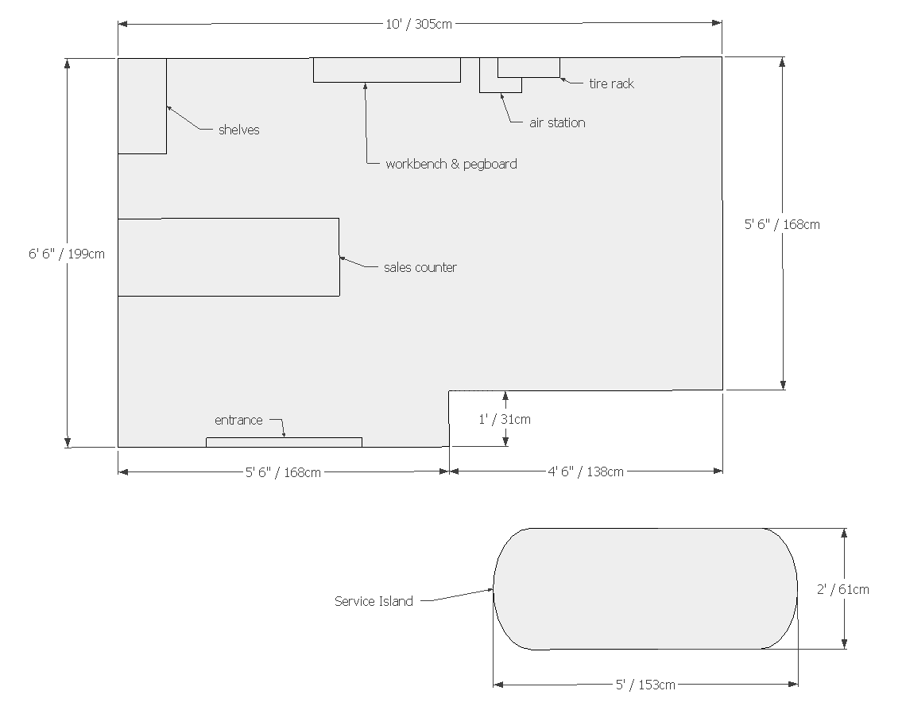

Apartment
Playhouse Features Included: Custom Flower Bed, Flowers
Playhouse Options: Kitchen, Increase Playhouse Size, Custom Paint Selections, Exterior Conversion, Theming
Playhouse Specifications:
Base size: 7’w x 6’3
Door size: 3’w x 4’5”h
Overall height: 7’7”
Playhouse Colors: Incredible White, Steely Gray, Cyberspace
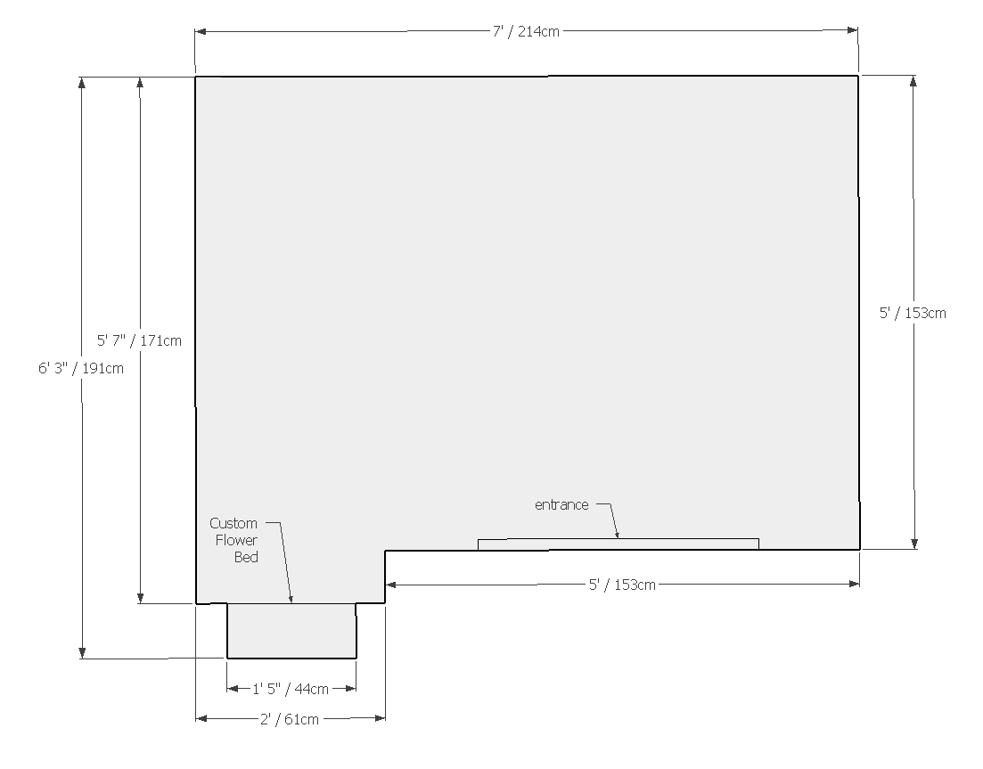

Animal Hospital
Playhouse Features Included: Exam Table, Kennels, Dog Skeletal Chart, “Pretty Pet Puddle” Washing Station, Diploma, Medicine Cabinet, Animal Doors (non-operational), Custom Signage
Lilliput Exclusive Interactive Accessories: (like listed on MSAH with item descriptions also)
- Lilli’pup Operations Table - $580 (including standard exam table credit)
Playhouse Options: Stuffed Play Animals, Animal Food Bowls, Theming
Playhouse Specifications:
Base size: 8’1”w x 6’d
Door size: 3’w x 4’6”h
Overall height: 7’2”
Playhouse Colors: Extra White, Positive Red
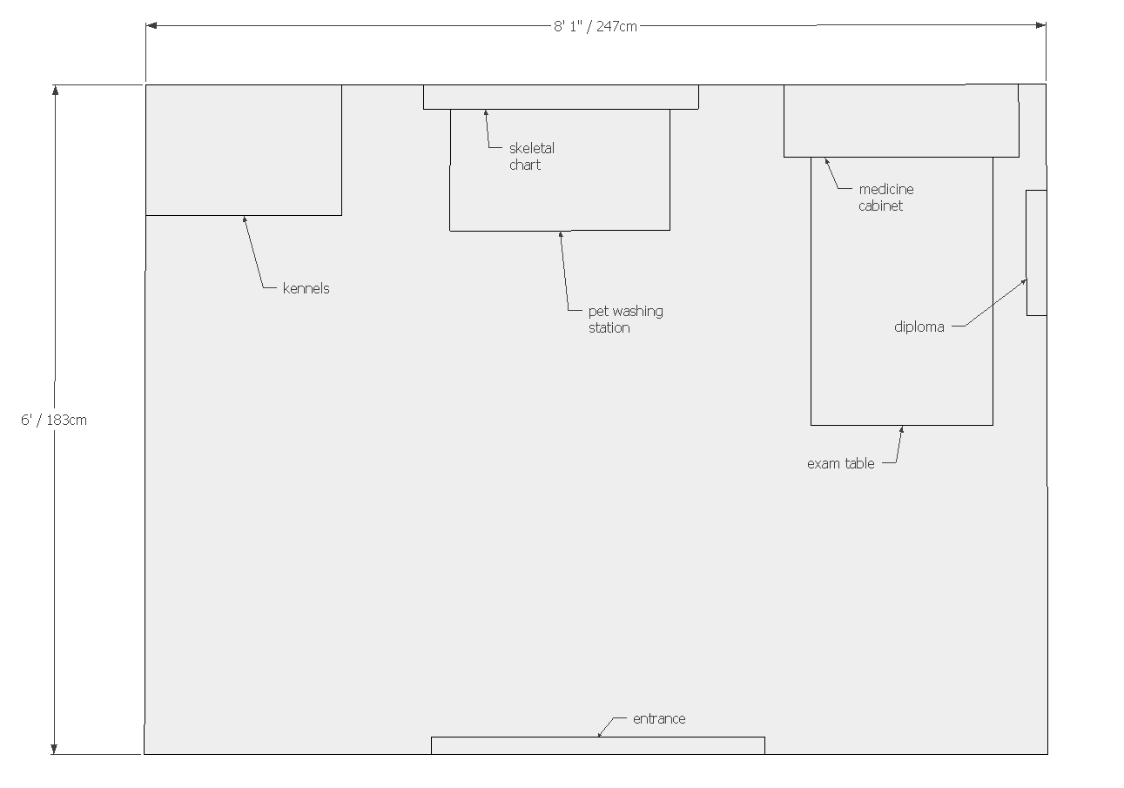

Fitness Center
Playhouse Features Included: Awnings, Inspirational Wall Décor, Mirrored Wall, Custom Signage, Exercise Bike, Treadmill, Barbell Weight Set
Playhouse Options: Increase Playhouse Size, Custom Paint Selections, Exterior Conversion, Theming
Playhouse Specifications:
Base size: 8’1”w x 6’1”d
Door size: 3’w x 4’h
Overall height: 8’1”
Playhouse Colors: Pizazz Peach, Extra White, Mandarin
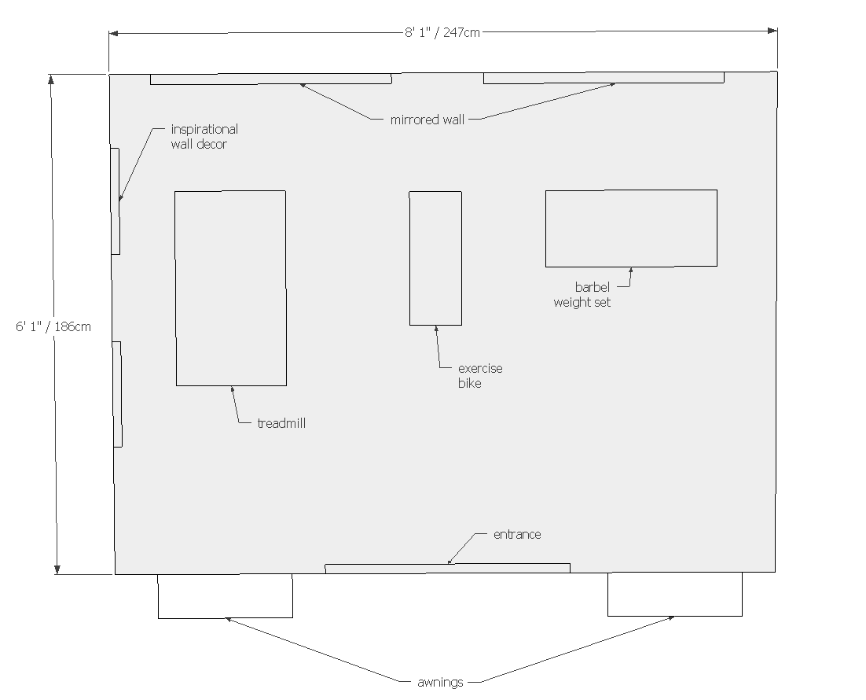

Coffee Shop
Playhouse Features Included: Sales Counter, Rear Counter with Sink & Storage Bins, Custom Signage
Playhouse Options: Faux Food, Increase Playhouse Size, Custom Paint Selections, Exterior Conversion, Theming
Playhouse Specifications:
Base size: 8’w x 6’d
Door size: 3’w x 4’6”h
Overall height: 8’6”
Playhouse Colors: Stone Lion, Restful, Tricorn Black
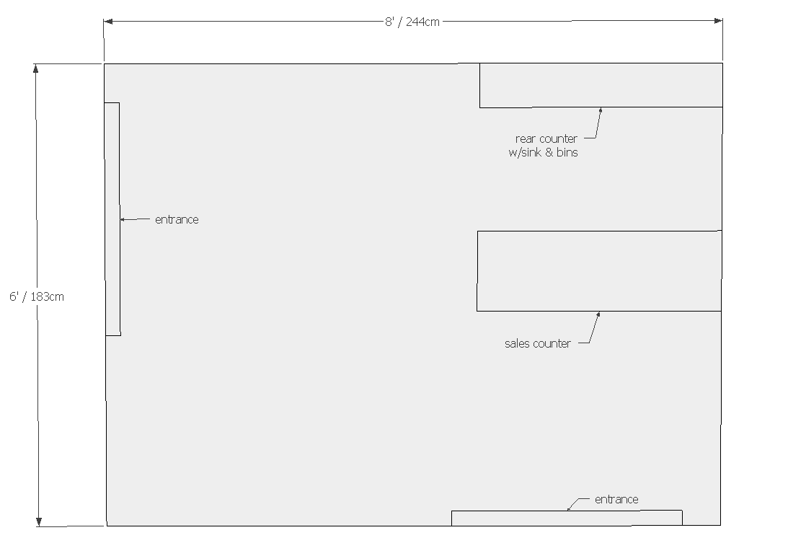

Fire Station
Playhouse Features Included: Call Box, Fire Bell, Hose & Reel, Flag, Custom Signage
Lilliput Exclusive Interactive Accessories: (like listed on MSFS with item descriptions also)
- Revolving Emergency Light - $360
- Main Street Fire Truck - $4,999
Playhouse Options: Fire Pole, Coats & Hats, Increase Playhouse Size, Custom Paint Selections, Exterior Conversion, Theming
Playhouse Specifications:
Base size: 6’7”w x 6’1”d
Overall height: 7’6”
Door size: 3’w x 4’7”h
Playhouse Colors: Sierra Redwood, Extra White, Canvas Tan, Tricorn Black
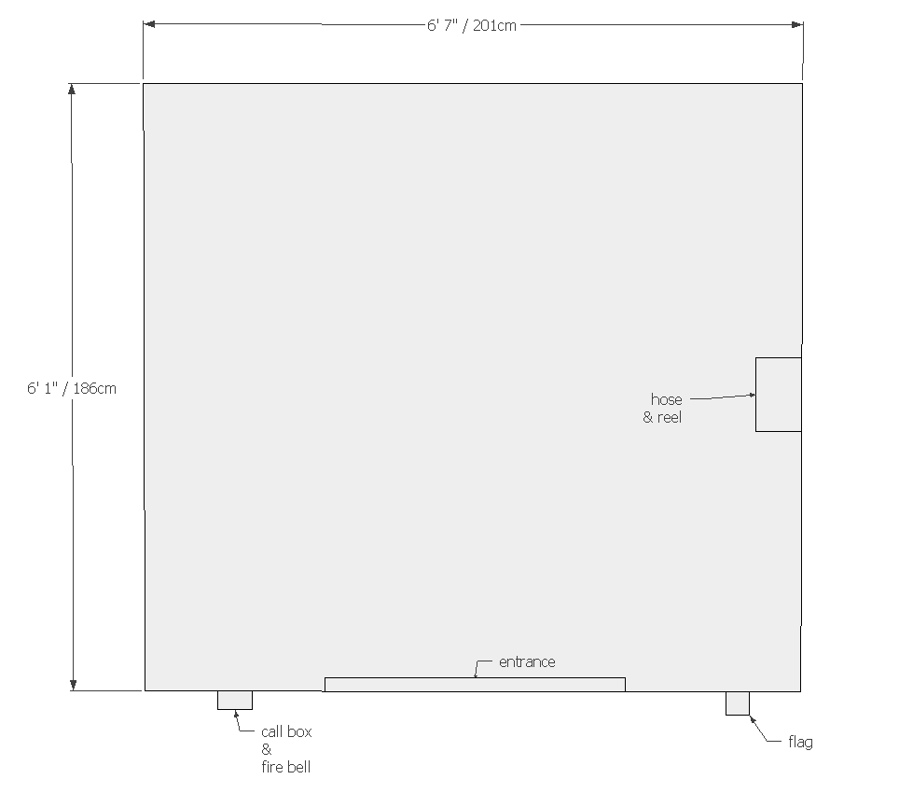
Market
Playhouse Features Included: Sales Counter, Produce Display Stand, Shelving Unit, Gift Card Display, Dairy Cases, Custom Signage
Lilliput Exclusive Interactive Accessories: (like listed on MSGM with item descriptions also)
- Scanning Checkout Counter - $1,950 (including standard counter credit)
- Child-Sized Commercial Shopping Cart - $165
- Market Merchandise Package - $575
- ATM - $2,999
Playhouse Options: Increase Playhouse Size, Custom Paint Selections, Exterior Conversion, Theming
Playhouse Specifications:
Base Size: 10’w x 6’4”d
Overall height: 8’1”
Door size: 2’7”w x 4’5”h
Playhouse Colors: Canvas Tan, Stone Lion, Incredible White, Hyper Blue
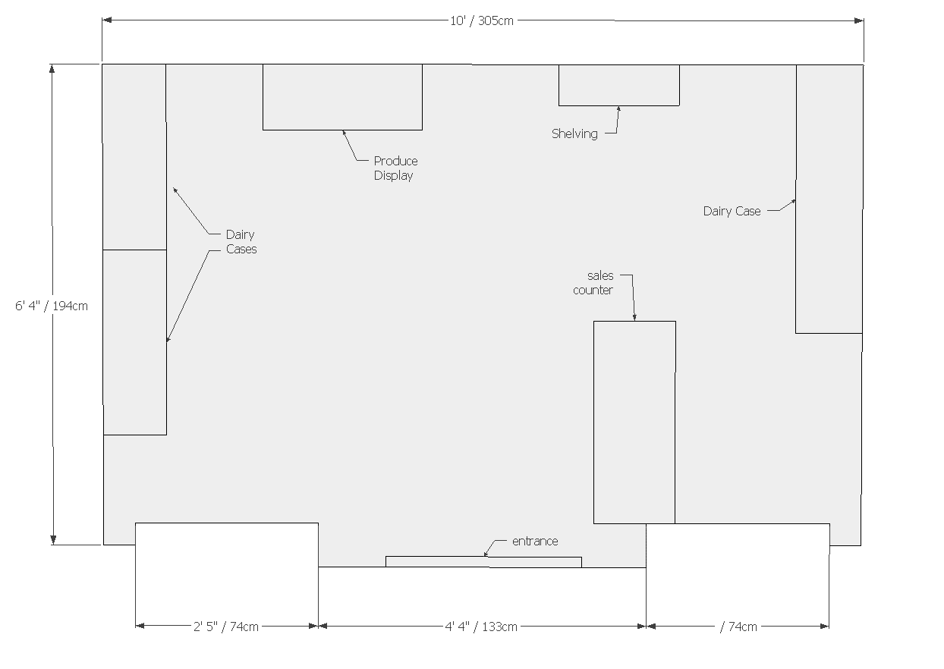

Pizza Shop
Playhouse Features Included: Faux Stone, Wood Laminate Siding, Sales Counter, Food Prep Oven Counter, Faux Brick Pizza Oven, Menu, Pizza Peel
Playhouse Options: Increase Playhouse Size, Custom Paint Selections, Exterior Conversion, Theming
Playhouse Specifications:
Base size: 8’1”w x 7’6”d
Door size: 3’w x 4’6”h
Overall height: 8’3”h
Playhouse Colors: Reclaimed Wood, Canvas Tan, Juneberry, Tricorn Black
